Pineapple Music

Group 3

Alex Fleming, Ethan Brown, David Reese, Neel Patel

Spring 2019

**Planning Scheduling and Peer Evaluation**

|  |  |  |  |  |  |  |
| --- | --- | --- | --- | --- | --- | --- |
| Assignee Name | Email | Task | Duration  (hours) | Dependency | Due Date | Evaluation |
| Alex Fleming | amfleming3861@gmail.com | Revise Problem Statement and Create Report | 2 hours | Needs other tasks finished first | 2/15 |  |
| David Reese | bunzssbm@gmail.com | Class Diagrams | 2 hours |  | 2/14 |  |
| Ethan Brown | ethanbrown78@gmail.com | Update To Do list, Case diagrams and Use Cases | 2 hours |  | 2/14 |  |
| Neel Patel | np69450@gmail.com | Database Specification and Analysis | 2 hours |  | 2/14 |  |

Problem Statement

1. What is your product, on a high level? A platform for music artists to upload their music and for users to listen to that music.
2. Whom is it for? It is for clients using a web browser who want to share their music and those who want to listen to music. It is for people who do not want to pay a fee to share/listen to music.
3. What problem does it solve? It provides a free option for artists to share their music on a copyright protected platform. Users can discover new local artists; established bands will be deterred from the site due to no compensation, so artists looking to be discovered can thrive in this community.
4. What alternatives are available? Soundcloud. You can upload music for free and certainly stream music for free. However, SoundCloud offers paid subscriptions to artists in return for spotlighting their music, schedule their releases, and other perks. Our product will spotlight artists based on popularity, recommendation systems, and if they have an upcoming live show in the user’s city.
5. Why is this project compelling and worth developing? This project is compelling and worth developing because of the large number of artists with access to computers who aren’t well known and want to gain a following.
6. Describe the top-level objectives, differentiators, target customers, and scope of your product. Our objective is to create a platform for users to discover new music and keep track of artists in their area. Our service is free and recommends artists based on recommendation systems and local activity. Our target customers are music enthusiasts and small bands willing to forgo profit to gain a bigger following. Our platform focuses on just music, no videos. Users have accounts, including artists who can post about new music and upcoming shows.
7. What are the competitors and what is novel in your approach? Soundcloud and Bandcamp are our biggest competitors, though they charge their users fees for certain functionalities. Our entire service is free.
8. Make it clear that the system can be built, making good use of the available resources and technology. We have a team of 4 software engineering students. We will use java to support the back-end and a SQL database to store data.
9. What is interesting about this project from a technical point of view? We can use data mining techniques to create groups of people with similar interests and recommend songs that similar users like. With user’s location data, we can also recommend bands when they have an upcoming show in that user’s area.



**Use Case Number:**​ 1 ​**Use Case Name**​: Finding an Artist

**Actors**​: User

**Description**​: The user searches the account database for an artist either using an account name or tags. The account database is searched using the name or tags depending on set preferences. A list of matching results is then displayed to the user.

**Alternate Path**​: you will either be displayed the matching results or a message ‘no matching results’.

**Pre-Condition**​: Must specify searching for an artist and must specify if searching by name or by tags. Must be under 25 characters if by name and under 25 if by tags.

**Use Case Number:**​ 2 ​**Use Case Name**​: Finding a Song

**Actors:** User​

**Description**​: The user searches the music database for a song either using an song name or tags. The music database is searched using the name or tags depending on set preferences. A list of matching results is then displayed to the user.

**Alternate Path**​: A list of matching songs is displayed or a message ‘no matching results’ is shown.

**Pre-Conditions**​: must specify searching for a strong and whether they are searching by name or tags. Must be under 25 characters for finding by name and under 10 tags if by tags.

**Use Case Number**​: 3 ​**Use Case Name**​: Streaming a Song

**Actors**​: User

**Description**​: A user selects a song, and the music database selects the correct mp3 file using the ID and plays it.

**Alternate Path**​: If a song cannot be streamed due to connection issues, then an error code will be shown.

**Pre-Condition**​: They must have connection and must the song must be public to them. (If they don't then they can't see it).

**Use Case Number**​: 4 ​**Use Case Name**​: Uploading/Removing a Song

**Actors:**​ User and Account Database

**Description**​: The user uploads an mp3 file and specifies the name + tags. The account database sets their status to artist and the mp3 file and specified tags + name is added to the database. If they are removing a song then the account databases is accessed to make sure that they are the artist of the song and if yes then the song is removed from the music database. **Alternate Path**:​ If the file doesn't meet the requirements or if there is a connection problem an error code is shown.(For removing: If they are not the artist of the song then they aren't shown the option to remove the song.)

**Pre-Conditions**​: Must be an mp3 file type and under 30 minutes long. The name must be under 25 characters. There must be at least 1 tag and under 10. (For removing: Must be the artist of the song.)

**Use Case Number**​: 5 ​**Use Case Name**​: Creating/Deleting a Profile

**Actors:**​ User and possibly the music database if an artist account is removed

**Description:**​ The user will enter a name and tags that describe them. They will set their profile to public or private. They will also provide an email and password. This information will be added to the account database. A forgot password code will be generated as well. Their profile can be edited at anytime using a profile editing page. Once changes are made they will hit submit and the changes will be recorded in the account database. For deleting an account, they will simply submit remove account and all their information will be removed from the account database and all their music, (if they have any), will be removed from the music database. **Alternate paths**​: If an email or username is taken they will be notified that an account with that data already exists and be prompted for either a different name or to use their email to log in. **Pre-Conditions:**​ Must have an unused email and the password must be at least 7 characters long and under 25. The username must be at least 1 character and under 25. Must have at least 1 tag and under 10. (For editing an account they must first be logged in.) For removing the account they must already have one.

**Use Case Number:**​ 6 ​**Use Case Name:**​ Resetting a Password

**Actors:** User​

**Description:**​ The user will click forgot password, then use a reset code provided in the email to access their account and go to the reset password page where they will enter and confirm a new password. The password will be updated in the account database and the reset code will be regenerated and replaced.

**Alternate Paths:**​ If they are already logged in they will just navigate to the reset page without using an emailed code. If the password is the same it will be denied for already being in use and if the password is too short it will be denied for not meeting the proper criteria.

**Pre-Conditions:**​ They must have access to their accounts email, or know their old password. They must have a new password that is at least 7 characters long and under 25 characters.

**Use Case Number:** 7 ​ **Use Case Name:**​ Creating/Removing a Playlist​

**Actors:**​ User and Account Database

**Description:**​ The user inputs the name of the playlist and whether or not it will be public. If it is public, anyone can listen to/ add songs and albums to it, if it is private, only the creator can add songs and albums to the playlist. They must be the creator of a playlist to remove it. The playlist is then added to the music database.

**Alternate Path:**​If the preconditions aren't met they will be prompted to meet them.

**Pre-Conditions:**​ The name must be under 25 characters. There must be between 1 and 10 tags. There must be at least one song added to the playlist.

**Use Case Number**​: 8 ​**Use Case Name:**​ Text post

**Actors**​: User

**Description:**​ A user can post a message to their account which will send a notification to all accounts which follow that account. Here artists can post about upcoming projects and shows **Alternate Paths:**​ None

**Pre-Conditions:**​ post must be under 150 characters

**Use Case Number:** 9​ **Use Case Name:**​ Create/Removing an Album​

**Actors:**​ User

**Description:**​ The artist inputs the name of the playlist and whether or not it will be public. They must then select at least one song. The playlist is then added to the music database. The artist can set public or private access to playlist at anytime using a toggle. Their ownership of the playlist is authenticated via the account database and the status is adjusted in the music database. Albums can be removed in the same manner as removing songs.

**Alternate Paths:**​ If there conditions aren’t met then they are prompted to meet the conditions. **Pre-Conditions:**​ The name must be under 25 characters. There must be between 1 and 10 tags. There must be at least one song added to the playlist. (For removing albums they must be the artist of that album)

**Use Case Number:**​ 10 ​**Use Case Name:**​ Liking a Song/Album

**Actors:**​ User and the account database

**Description:**​ A user can select ‘Like’ on a song and that song will have its ‘Like’ counter incremented. The song’s information will also be added to the account database section where liked songs are kept. The same process occurs if the user is liking an album but with the album replacing the song.

**Alternate Paths:**​ None

**Pre-Conditions:**​ User must have an account.

**Use Case Number:**​ 11 ​**Use Case Name:**​ Commenting on a Song/Album **Actors:**​ User

**Description:**​ A user can enter a comment to be added to a song or album. Their comment is added to the music database and is displayed to all other users.

**Alternate Paths:**​ If the pre-conditions are not met the user is prompted to meet them by the system.

**Pre-Conditions:**​ The comment must be under 50 characters long.

**Use Case Number:**​ 12 ​**Use Case Name:**​ Removing a Comment on a Song/Album

**Actors:** User and account database​

**Description:**​ Either the user who created the comment or the artist of the song has the option of removing a comment from a song or album so that it can no longer be seen. The account database is accessed so that their ownership is verified before being shown the option to remove the comment.

**Alternate Path:**​ None

**Pre-Conditions:**​ The user must either be the creator of the comment or the artist of the song.

**Use Case Number:**​ 13 ​**Use Case Name:**​ Following an Artist

**Actors:** ​User and music database

**Description:** A user can select “Follow” next to an artist name. The users account will then receive a notification whenever that artist makes a post of any kind(text post, uploading a song). They also have an option to unfollow at anytime.

**Alternate Paths:** None​

**Pre-Conditions:**​ Must have an account.

**Use Case Number:**​ 14 ​**Use Case Name:**​ Adding/Removing Songs for a Playlist

**Actors:**​ User

**Description:** ​The creator of a playlist can add any public song to their playlist using an option available on all public songs. The system will simply append or remove the song from the playlist.

**Alternate Paths:**​ If there is only one song in the playlist and the user is removing the song, they will be notified that if they do the playlist will be deleted and asked if they want to continue. (If they do then it will be deleted and if they don’t then it won’t). **Pre-Conditions:**​ They must be the owner of the playlist.

**Use Case Number:**​ 15 ​**Use Case Name:** Sharing a Song/Album/Playlist​

**Actors:** ​User and account database

**Description:**​ The user can search any public profile and then select an option to share either any public media on the site or any of their own media on the site to share with them. (Even if the media is private if the sender is the artist then whoever they share it with will be able to access it indefinitely. In that case the receiver is given a code that allow them to see the media in the music database). The receiver is given a message with the songs basic information from the music database. **Alternate Paths:**​ none

**Pre-Conditions:** The sender must be either the owner of the material or the material must be​ public and the receiver must have a public profile.

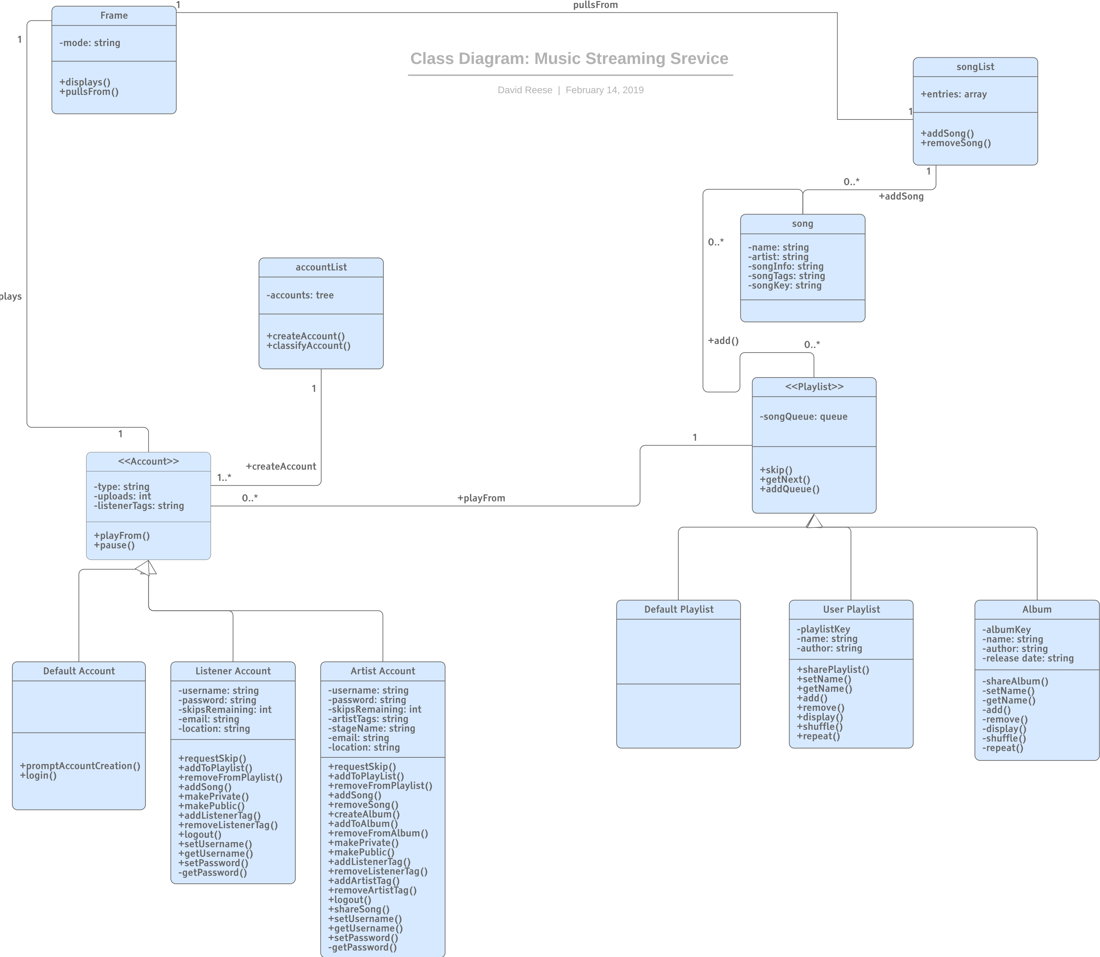

Database specification and analysis

* We will be using a case diagram. We will be using the login as a Primary Keys because both user and account database can access. On the other hand, Tags, Name, Add/Remove/ Song List is the Foreign Keys due to the User being the only one to access.
* Java, Python, HTML, CLI-Unix, SQL, C, Beta-testing, Analyzing/ transposing code are the language we will be using.

MySQL and Oracle will also be used for our music streaming service.